Shriners Hospital for Children

Anesthesia Service Orientation Manual

Please read and enjoy your time at Shriners

SBH Orientation Check List
Lockers
Please Change at Shriners
Bronchoscopes
Clean and Dirty Scopes
Workroom
Bronch attachments
Central Lines
Transducers
NS
PICCO
LMA’s
Biojector
Wires
Drugs

OR Rooms
Anesthesia carts
Computers / Access code
Anesthesia Machines
Turn OFF
Silence
Back up Etco2
Bronch Carts
Dirty LMA’s

Recovery Room
Hawk
Drugs
Drug Cart
Code Cart
Paperwork
Pharmacy
Sign out keys

ICU
Bronch Cart

3 East / DSU / Clinic / Café

Index

Topic Page

Central Line Insertion 4-8

Nitrogen Pressure Bag System 6

Ordering Blood Products 9

Patient Orders 9

Biojector (Needless injection System) 10

LMA’s 10

Controlled Substance Policy 11

Fiberoptic Scopes, Set-up, and Care 12-13

Arterial/Central Venous Catheter Insertion Protocol

Although the nurses will set your back table, blood warmer, anesthesia circuit, etc., you are responsible for the machine check and the determination of intravenous therapy, pressure lines, central line and pressure monitoring catheters before the patient arrives in the room.

- SUPPLIES (Located in Anesthesia Workroom)
1.0 - 1 or 3 cc Syringe for heparin
1.1 - 500 ml bag .9% NaCl
1.2 - (1) #16 Gauge Needle (optional)
1.3 - Baxter Interlink Access Cannula
1.4 - Baxter VAMP Pressure Monitoring Kit
1.5 - Baxter Pressure Monitoring Kit

The following items are placed on the Sterile Central Line field (See Photo Below)
1.6 - (1) Walrus “Hi-Flo” stopcock with 6” monitoring line (Central Line) (1010)
1.7 - (1) Walrus “Hi-Flo” 3-way stopcock (Central Line) (874)
1.8 - (1) Walrus stopcock with 8” monitoring line (A-line) (8778)
1.9 - Appropriate Cook Venous Catheter Set(s)
1.10 - (2) 3cc Syringe
1.12 - (2) 10cc Syringe

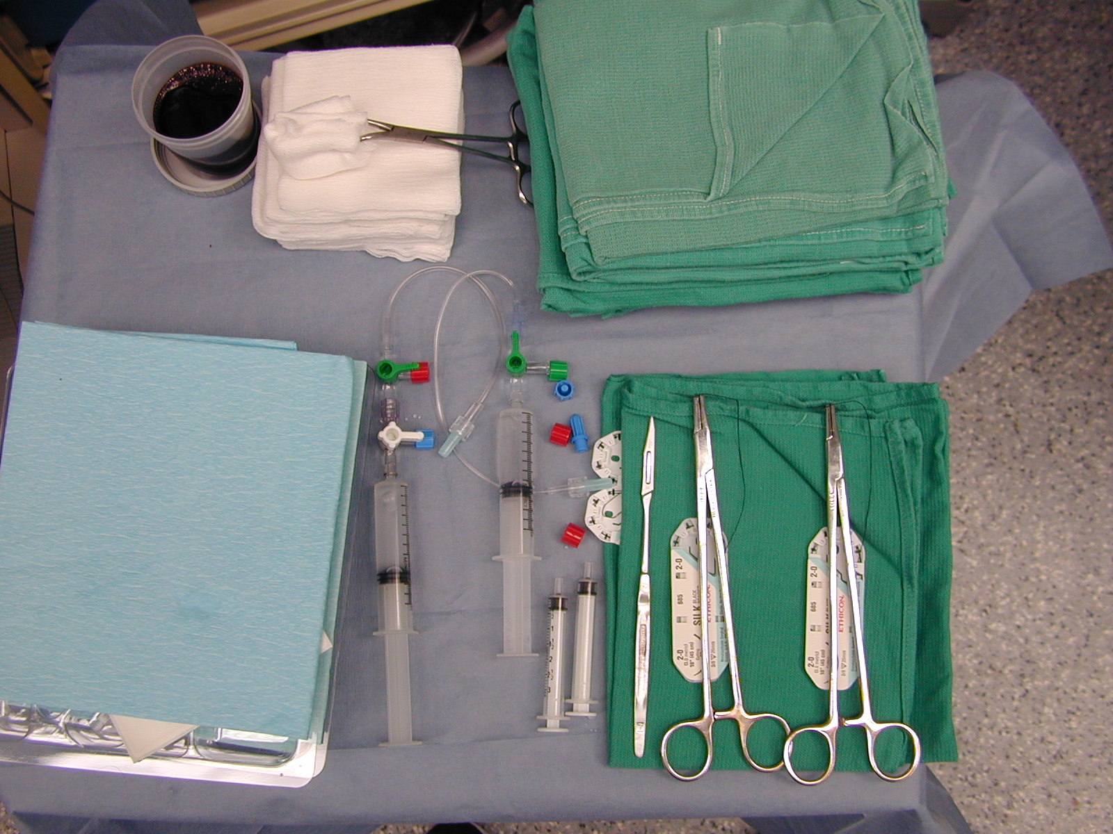

Important
Always use a VAMP Pressure Monitoring Kit for each patient to draw labs. If you are going to insert both arterial and central lines use the VAMP on the Arterial line. If you are going to place only a central line use the VAMP on the Central line.
How to choose a catheter:

CVP
a. <2 years = 4 Fr.
b. <4 years = 5.3 Fr.
c. >4 years = 6 Fr.
d. >50 kg. With expected
high blood loss = 7 Fr. or greater

To determine the length of the central line catheter, measure form mid-clavicular line to lower 1/3 of the sternum (Right atrium) to determine appropriate length.

A-Line
a. <5 kg. = 2.5 Fr. X 5cm.
b. >5 kg. = 3 Fr.
c. radial = 5cm.
- femoral = 8cm.

2. Open on small sterile field:
2.1 - Appropriate A-line & CVP Venous Cath (A)
2.2 - Walrus Stopcock with 8” Monitoring line with 10cc of flush for A-Line (B)
2.3 - (2) -3cc syringes (C)
2.4 - (2) -10cc syringes attached to the Stopcock monitoring lines
2.5 - Walrus “Hi-Flo” Stopcock with 6” Monitoring line (D)
2.6 - Walrus “Hi-Flo” 3-way Stopcock attached to 6” above for CVP(D)

3. Prepare 500 ml .9% NaCl.

4. Label bag with additive, concentration, date, and your name.

5. Invert bag and with use needle to expel all air by gently rocking and squeezing.

6. Tighten all connections of your monitor lines and Pressure Monitor Kits.

7. Double spike bag with pressure monitor line(s) filling drip chambers at least ¾ full.

8. Pressurize bag using low pressure Nitrogen system

How it works/Troubleshooting the Nitrogen system:
- Check that the pressure is regulated to no more then 300mmHg utilizing Zimmer tourniquet box.
b. This box regulates two blood and fluid pressure bags so if either bag does not inflate to
300mmHg, check the pressure setting at the box and the stopcock(s) - one of which may
be open to suction.
c. Be certain that your solution bag is enclosed within the pressure bag-not sticking out,
above or below.

9. Label lines with color-coded stickers provided in kit

10. Mount transducers (cable down) in holder located at the head of the table

11. Flush lines
11.1 - don a pair of sterile gloves and piggy connect the “Hi-Flo” 3-way stopcock to the
stopcock with 6” monitor line.
11.2 - using sterile technique withdraw (2) 10cc Heparin solution from transducer to flush
stopcocks and 6” monitor lines [you opened (2) 10cc syringes on your sterile
back table for this]
  - - double stopcock large bore tubing with flush syringe set-up for CVP
  - - single stopcock small bore tubing with flush syringe set-up for A-Line
12. Connect transducers to appropriate monitor cables
Anesthetize the patient
Consider: KETAMINE 2 MG/KG IV OR 10 MG/KG IM IF NO IV ACCESS.
Then transfer the patient on to the burn table.

13. Patient must be monitored and positioned:
13.1 - Monitor:
a. EKG - place staples in unburned tissue over scapula and left lateral thorax
- right shoulder white
- left shoulder black
- left lateral lower thorax red
b. Oxygen via face mask or intubated first
c. Oxygen saturation probe to extremity receiving A-line (if possible) to watch
for arterial spasm.
d. Temperature probe - rectal or bladder if Monotherm Foley present
13.2 - Position:
a. shoulder roll to mid scapular level
b. occipital towels
c. towels to buttocks in infants and small children receiving femoral line
(thrusts pelvis forward)
d. in infants and small children receiving a subclavian line, swaddle the wrist
in a towel, pull caudal and tuck towel under buttocks
e. Place the table in trendelenburg for CVP

14. Prep BILATERAL A-Line and SINGLE SIDE CVP insertion sites with Betadine
solution:
14.1- paint and go - don’t scrub. Betadine works via lysis of the cell wall over time
- - isolate insertion site using green towels. Use the full towel (Do not fold) and drape
to the table edge. This prevents contamination of the J-wires, which in some kits, are
up to 60 cm long.

- Insert lines with standard Seldinger technique and suture in place: (2-0 Silk Suture is used for most catheters but 3-0 Ethalon maybe substituted for lines placed in unburned skin for cosmetic reasons.)
  - - catheter suture points are lateral wings,
the hub just distal to the wings, and
proximal end behind luer lock of IV Tubing.
With an alternative is between the tubing and the catherter. See Arrow Below.

  - - on the wings, your first knot down should be
a cardiac surgeon’s knot – which is two
“square” knot loops. Finish with three
surgeon’s knots and cut with #11 blade or scissors.
  - - on the hub, tie your cardiac surgeons knot
and one surgeons knot. Pass the
needle under the hub backwards, tie another
cardiac surgeons knot and finish with
three surgeons knots.
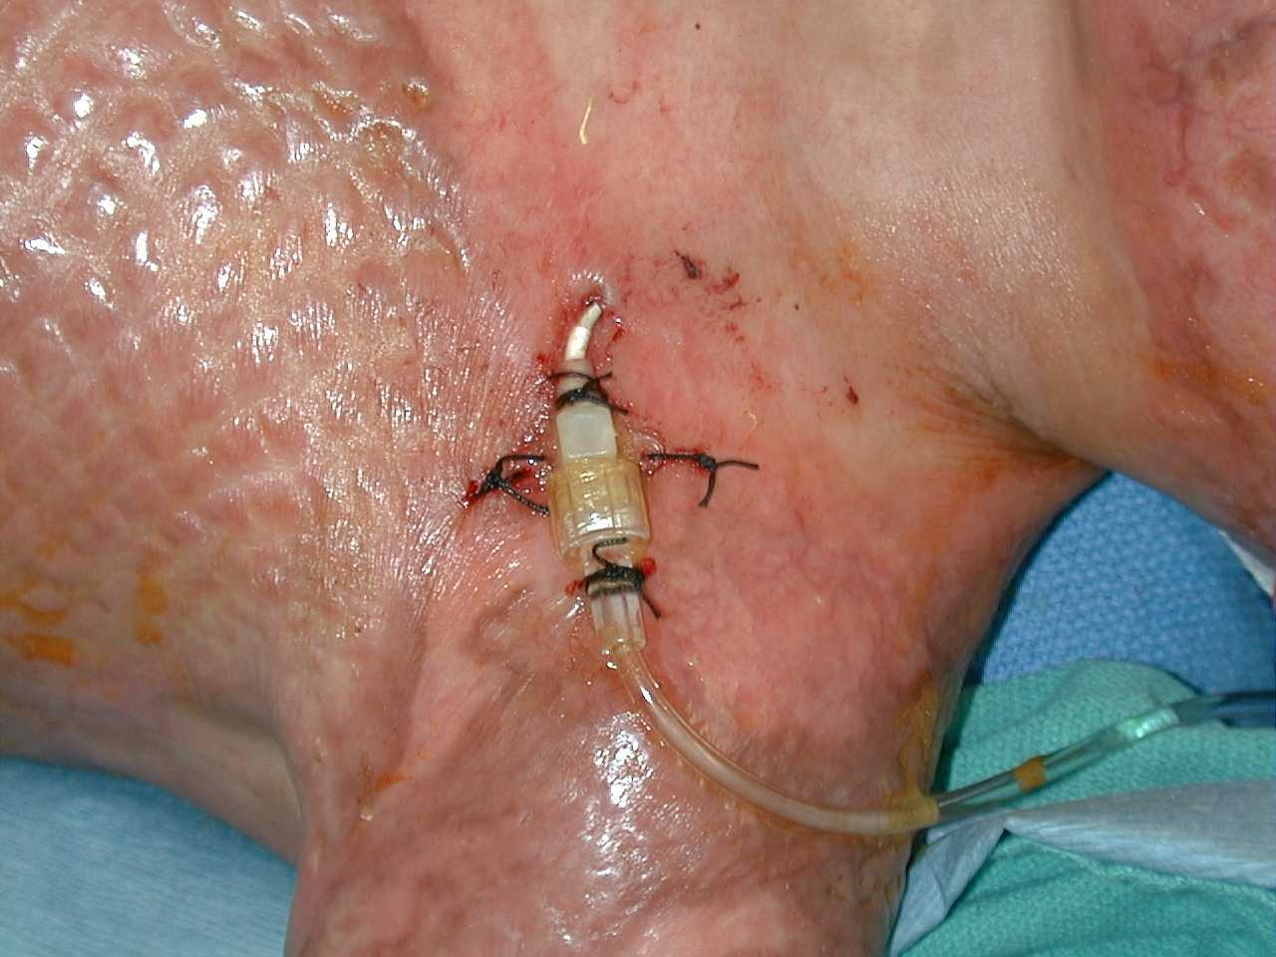

- New CVP –
Please send blood for a venous blood gas if no A-line and a blood culture if ordered by the surgeon.
Most acute case are started with a baseline arterial blood gas and PRN throughout the case related to volume and blood product infusions.
Please flush and leave in old lines until the end of the bigger cases. They can be used for running drips, pushing drugs, and as a backup if there is any difficulty with the new line.
17. After each position change the patency of the central line should be checked by
aspirating back on the line and wave form evaluation.

18. Connect transducers and zero. It is necessary to calibrate the system. If the system
will not zero and offers no logical solution (prompt in upper left hand screen), get a
new transducer kit.

19. To transport the patient at the end of the case, roller clamp lines to off, remove IV
bag from pressure bag, bring complete set-up with patient

20. We change existing Lines as follows:
  - Evaluate the site
  - If the sites require changing the routine is:
      - day #3 - Seldinger (over-wire) using same site(s)
      - day #6 or 7 - fresh stick(s)

Ordering and transfusing blood products:
Blood is ordered by the following formula:
((Pt. BSA x 10,000) x Percent open injury x Time Factor Variable) / 500 = Units
Percent: use decimal point above IE: 0.50 = 50 Percent open
Time Factor Variable
  - Three days or Less since Burn
  - Greater than Three days since burn
  - Dirty infected burns seven or more days since burn

Notes and ORDERS for OR Patients
A. Pre-operative
- Pre-operative notes on all patients. These can be done on the Preoperative
Anesthetic Evaluation form. Any additional information to be written on the back of that
same form.
2. Pre-operative ORDERS Appropriate for patient, procedure, & expected duration of
case.
- Scopolamine 0.4 – 1.0 mg PO for possible fiberoptic Intubation
- Versed 0.5 to 0.75 mg/kg PO to maximum 15-20 mg round to the nearest 5 mg if it falls within the medication range.
- Tylenol 10-20 mg/kg PO to MAX 1000mg

B. Admission to PACU
1. Upon arrival in PACU, report the following information to bedside nurse:
- Agents administered
- Medications administered
- fluids, blood, estimated blood loss
2. Admission Note to PACU may include(This is now on the back of the anesthesia record):
- Age, sex, type of procedure, lines placed, EBL, IVF, blood given, intra-operative events & identified complications.
3. Written orders:
- Morphine Sulfate in divided doses q 5 minutes prn to maximum calculated dose of 0.1mg/kg IV for smooth emergence (or appropriate analgesic).
- MID (Medical Immobilization Device) for (reason: ETT protection, etc.)and amount of Time (no longer than 60 minutes) rewrite orders every 60 minutes as needed.
- PCA orders when indicated - ask nurse for order sheet
- Anti-emetic of choice

C. Discharge from PACU / POST-OP (on the back of the anesthetic record)
1. TITLED discharge note that includes VS status and LOC.
- 2. Order in the physician order for transfer or discharge to appropriate unit.
- 3. If going to DSU then HOME the orders are below:
The two orders are:
- Transfer to DSU
- Discharge home when criteria met
D. 24 hour post-op visit as indicated by the patients post-operative status
(on the back of the anesthetic record)
- Status of Patient and post-op side effects and complications, etc. on patients that
have unexpected stays over night, etc.

Miscellaneous Items of Note

1. You must check your room prior to each patient. Do your machine check(ms.maid, etc.)
2. While you are on-call you must remain in the Shrine and on beeper until all patients are
discharged from PACU.
3. If not on-call you must check out with one of the Staff Anesthesia Providers prior to
leaving.
4. Pre-operative patient visits are done by the person on-call. All Anesthesia Providers
help with this if they are in house.
5. Pre-operative report may be called to the attending that will be in attendance for those
patients. See call list in Anesthesia Workroom.

Biojector - Needle-Free Medication Injector
1. Select Correct Syringe
a. No.3 (brown) for kids ≤7kg for thigh injection or
No.3 (brown) for deltoid injection (>7kg & ≤23 kg)
b. No.4 (blue) for kids >7kg for thigh or gluteal injections
No.4 (blue) for deltoid injections ≥23kg
2. Make sure that the pressure gauge indicator is in the green otherwise change CO2
cartridge
3. To numb area for IM ketamine use: Buffer lidocaine by drawing up:
0.1ml of NaHCO3 and 0.9ml of 2% lidocaine
NOTE: Patient Movement during injection may cause a pressure incision.

Laryngeal Mask Airways
1. Indications / Contraindications
- Read LMA manual available in workroom
2. Sizes
- Neonates/infants 6.5kg cuff 2 to 4ml
(1½) Infants 5-10kg cuff up to 10 ml
(2) Babies/children 10kg to 20kg cuff up to 10ml
(2½) Children 20kg to 30kg cuff up to 15ml
(3) Children/small adults 30kg cuff up to 20ml
(4) Average/large adults >40kg cuff up to 30ml
3. Do Not Throw Away or put the LMA’s in the Anesthesia Workroom.
Make sure that the circulating nurse is given the LMA to re-sterilize.

Controlled Substance Policy (HP1C3.027)
- You will be issued a set of keys for the month you are at Shriners. These keys are to the narcotic / MH Cabinet in the workroom and to the anesthesia machine drawers. The anesthesia machine keys are labeled OH-Ohmeda and ND-North American Drager; the other keys are for narcotic access. One of the narcotic keys opens the outer door and the other key opens your assigned narcotic drawer. You are responsible for your medications throughout your month at Shriners.
- Procedure:
  - When you are issued your keys you will open your narcotic drawer with another licensed person to confirm the content of the drawer. Note that the narcotic boxes in the drawer are sealed. Evaluate the content of the box prior to opening. All of the vials should be sealed with their original cap, if not, return the box to the pharmacy without breaking the outer box seal.
  - The box contains 3 – 8or10mg MSO4 vials, 2 – 5mg Versed vials, 2 – 50mg/ml Ketamine vials, and 2 – 100mg/ml Ketamine vials and 4 Propofol 10 mg/ml.
  - The medication box is used for the complete day. Each vial is single patient use.
The waste of any remaining medication may be done with any licensed person or pharmacist.
  - At the end of the day please return the un-used medications and box to the pharmacy for restocking with the pink copy of your anesthesia record for reconciliation of the narcotic sheets and anesthesia record. Press hard so that the amount and medications are legible on the pick copy.
  - The last day of your rotation at Shriners return your keys and all open and un-opened medication boxes to the pharmacy for final reconciliation.

Double Bronch Set-up

Fiberoptic Bronchoscope Set-Up for both Acute and Recon patients
- Cover top of cart with clean towels or sheet
- Select appropriate size scope (see below)
- 2-6cc syringes calculate total safe maximum dose for lidocaine dilute into 2 syringes
- 1-10cc syringes with normal saline for irrigation
- Luki-tubes if doing pulmonary cultures
- 1 warm liter bottle of normal saline from warmer in center well to warm the ETT
- 1-2 water soluble lubricant packets
- Hook up video to Bronchoscope eye piece and focus scope
- Double bronch set-up for tubes less then 4.5 mm
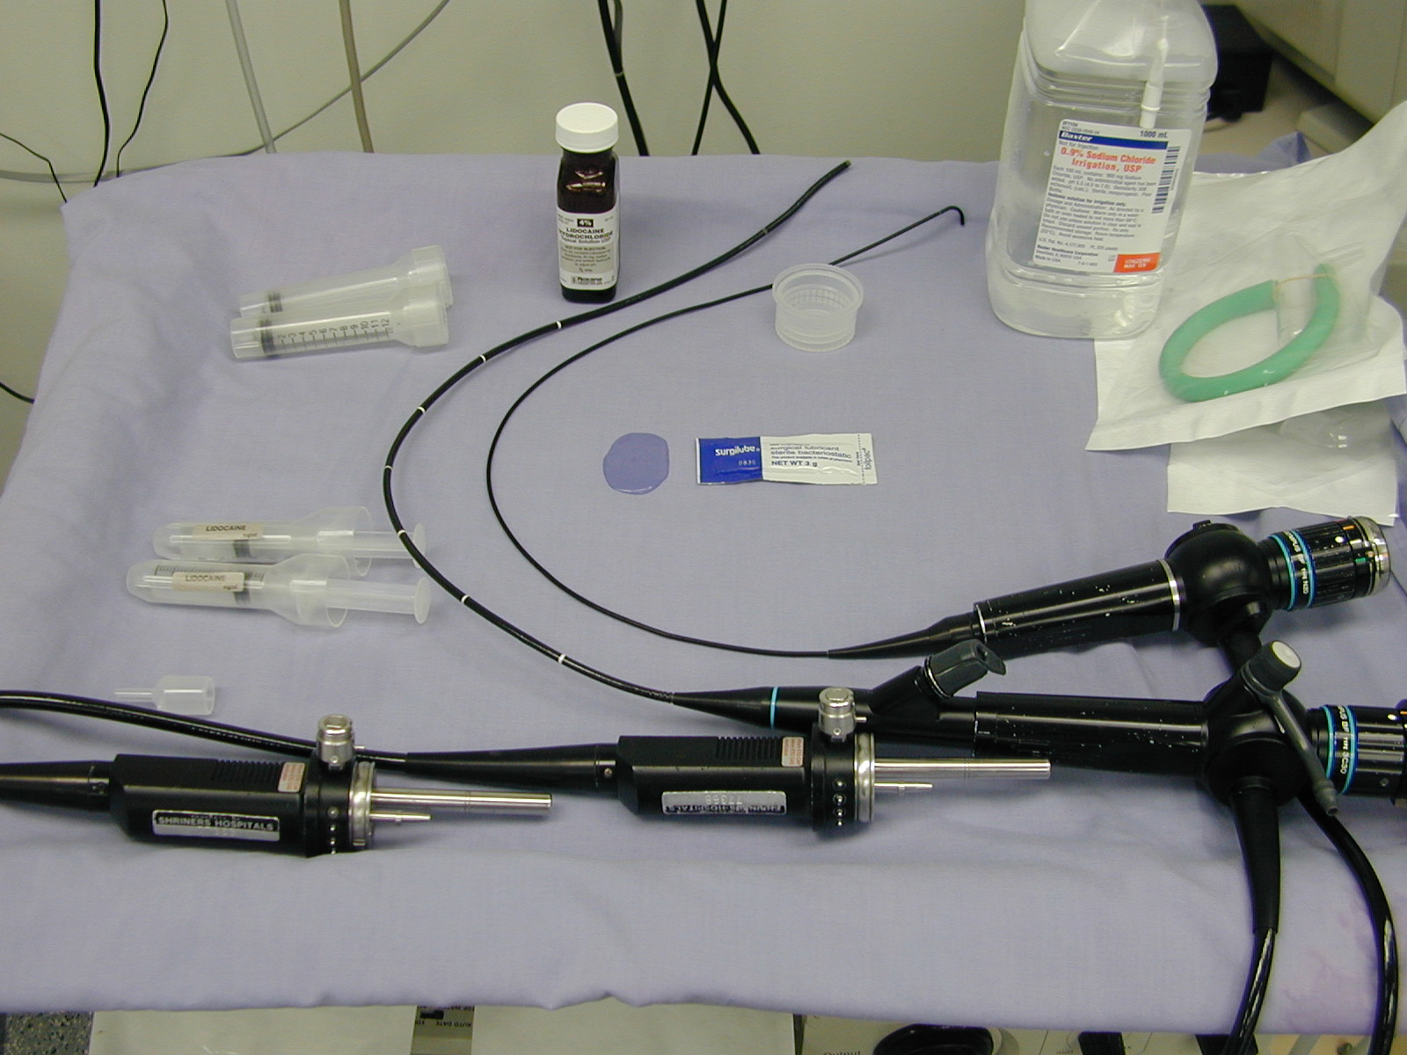

Available Scopes
SIZE Dimensions Type Smallest Notes
ETT
X-Small (2.2mm) N2O 2.5 No Suction Channel
So you will need the
Next size up to localize the
Larynx with lidocaine.
Portable (3.1mm) LF-DP 4.0

Small (3.6mm) 3C40 4.5
(3.6mm) 3C30 4.5
(3.8mm) 3P160 4.5 (Digital Cart Required)

Medium (4.9mm) P10 5.5
(4.9mm) P30 5.5
(4.9mm) P40 5.5
(4.9)mm) P160 5.5 (Digital Cart Required)

Large (5.9mm) 10 6.5

Care of the Fiberoptic Bronchoscope:

It is imperative that you care for the Fiberoptic scopes with the utmost care.

These are delicate glass fiber instruments.

The connections of the fibers are damaged by torque at the tip where the most angulations occur and at the handle when the scope is not placed onto hard surfaces properly.

The minimum diameter curve of any fiberscope is 10 cm except at the bending tip. If you coil the insertion tube or light fiber tube less than 10 cm diameter you will start to break light or visual transmitting fibers.

Please suction saline through the bronchoscope at the completion of each use to keep the port clean. This helps to prevent repairs of the bronchoscopes.

Please return scopes to dirty bronch cart or wall storage next to the clean bronch cart at the end of each case and call respiratory therapy (pager #643-2667)

Thank You.

