**UTMB ANESTHESIOLOGY RESIDENCY**

**CURRICULUM FOR ROTATIONS**

Competency-based goals and objectives for each UTMB Clinical Anesthesiology, UTMB Integrated Clinical Base and Saint Joseph Hospital Transitional Clinical Base assignment at each educational level can be accessed anytime on New Innovations under Curriculum (Main Tab). Additional educational material including available handbooks for each rotation is included. New Innovations sends an email reminder to each resident seven days prior to starting a new rotation. Residents are expected to read and be familiar with this material prior to starting a new assignment. Please refer to Program Overview for a sample schedule for each year.

DIRECTIONS to find CURRICULUM and HANDBOOKS on New Innovations

STEP 1: Log onto New Innovations and Click Curriculum under Main:

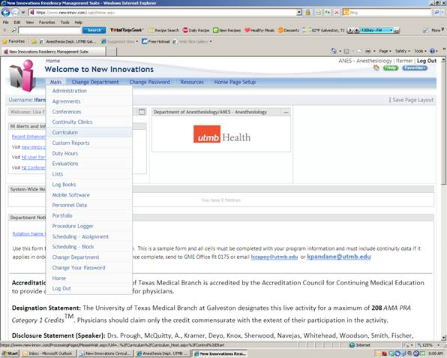

STEP 2: Select the Curriculum you would like to view.

SAMPLE Notification Email

|  |  |
| --- | --- |
| To |  |
| Subject |  |
| [Person's Name], this is to inform you that new curriculum has been posted for your [Rotation Name] rotation that begins: [Date of Rotation  Please do not reply to this email. It was sent through the New Innovations web site and the sender has no reply address.  [link to web site] | |

|  |  |  |
| --- | --- | --- |
| [Curriculum](https://www.new-innov.com/Curriculum/Curriculum_Host.aspx?Control=Start): [ANES - Anesthesiology](https://www.new-innov.com/ProcessingPages/PleaseWait.aspx?Url=%2fLogin%2fHost.aspx%3fControl%3dChangeDepartment%26Return%3d%2fCurriculum%2fCurriculum_Host.aspx%3fControl%3dStart) |  |  |
| [Acute Pain Regional Anesthesia CA3](https://www.new-innov.com/2003/utmb/upload/CURRIC-11-23-2011-17-29-39--57-429.docx) | |
| [Acute Pain Regional Anesthesia CA2](https://www.new-innov.com/2003/utmb/upload/CURRIC-11-23-2011-17-28-23--57-429.doc) | |
| Cardiology Consult UTMB | |
| [Cardiology SJMC](https://www.new-innov.com/2003/utmb/upload/CURRIC-7-11-2012-12-15-11--57-1134.doc) | |
| Cardiology UTMB | |
| [Cardiothoracic Anesthesia Syllabus-UTMB CA2-CA3](https://www.new-innov.com/2003/utmb/upload/CURRIC-7-13-2012-12-54-41--57-1134.doc) | |
| Cardiothoracic Surgery UTMB | |
| [CT Methodist CA3](https://www.new-innov.com/2003/utmb/upload/CURRIC-9-28-2012-12-2-11--57-1134.doc) | |
| [CT Methodist](https://www.new-innov.com/2003/utmb/upload/CURRIC-9-28-2012-11-52-35--57-1134.doc) | |
| [Driscoll Hospital](https://www.new-innov.com/2003/utmb/upload/CURRIC-7-12-2012-15-56-45--57-1134.doc) | |
| [ECHO](https://www.new-innov.com/2003/utmb/upload/CURRIC-7-23-2012-16-21-53--57-1134.pdf) | |
| [ER SJMS](https://www.new-innov.com/2003/utmb/upload/CURRIC-7-11-2012-13-42-43--57-1134.doc) | |
| ER UTMB | |
| [General OR](https://www.new-innov.com/2003/utmb/upload/CURRIC-7-11-2012-15-40-14--57-1134.doc) | |
| [General OR CA3](https://www.new-innov.com/2003/utmb/upload/CURRIC-7-11-2012-15-55-43--57-1134.doc) | |
| [Internal Medicine SJMC](https://www.new-innov.com/2003/utmb/upload/CURRIC-7-11-2012-13-54-1--57-1134.doc) | |
| Internal Medicine UTMB | |
| MICU UTMB | |
| [Neurosurgical Anesthesia Methodist](https://www.new-innov.com/2003/utmb/upload/CURRIC-9-28-2012-12-6-53--57-1134.doc) | |
| [Neurosurgical Anesthesia UTMB](https://www.new-innov.com/2003/utmb/upload/CURRIC-7-12-2012-10-31-27--57-1134.doc) | |
| [Neurosurgical Anesthesia UTMB/Methodist CA3](https://www.new-innov.com/2003/utmb/upload/CURRIC-9-28-2012-12-13-21--57-1134.doc) | |
| [NICU SJMC](https://www.new-innov.com/2003/utmb/upload/CURRIC-7-11-2012-15-22-21--57-1134.doc) | |
| NICU UTMB | |
| NICU UTMB Survival Guide | |
| [OB Anesthesia](https://www.new-innov.com/2003/utmb/upload/CURRIC-7-11-2012-11-44-17--57-1134.pdf) | |
| [OB Anesthesia CA3](https://www.new-innov.com/2003/utmb/upload/CURRIC-7-11-2012-11-45-44--57-1134.pdf) | |
| [OR ENT](https://www.new-innov.com/2003/utmb/upload/CURRIC-7-12-2012-9-51-25--57-1134.doc) | |
| [OR ENT CA3](https://www.new-innov.com/2003/utmb/upload/CURRIC-7-12-2012-9-54-36--57-1134.doc) | |
| [OR Orientation](https://www.new-innov.com/2003/utmb/upload/CURRIC-7-12-2012-14-30-41--57-1134.doc) | |
| [OR Pedi CA2 and CA3](https://www.new-innov.com/2003/utmb/upload/CURRIC-7-12-2012-11-6-6--57-1134.docx) | |
| [OR-Airway](https://www.new-innov.com/2003/utmb/upload/CURRIC-4-4-2012-17-12-27--57-3435.docx) | |
| [PACU](https://www.new-innov.com/2003/utmb/upload/CURRIC-7-12-2012-14-52-10--57-1134.doc) | |
| [Pain Management Handbook CA1-CA3](https://www.new-innov.com/2003/utmb/upload/CURRIC-7-13-2012-10-55-2--57-1134.docx) | |
| [Preoperative Evaluation Clinic](https://www.new-innov.com/2003/utmb/upload/CURRIC-7-11-2012-12-54-32--57-1134.doc) | |
| [Radiology SJMC](https://www.new-innov.com/2003/utmb/upload/CURRIC-7-11-2012-16-46-4--57-1134.doc) | |
| [Remote Anesthesia](https://www.new-innov.com/2003/utmb/upload/CURRIC-7-12-2012-11-22-9--57-1134.doc) | |
| [Shriners Hospital CA2 and CA3](https://www.new-innov.com/2003/utmb/upload/CURRIC-7-12-2012-14-6-13--57-1134.doc) | |
| [SICU Handbook CA1-CA3](https://www.new-innov.com/2003/utmb/upload/CURRIC-7-13-2012-12-25-50--57-1134.doc) | |
| [Surgery SJMC](https://www.new-innov.com/2003/utmb/upload/CURRIC-7-11-2012-17-4-24--57-1134.doc) | |
| Surgery UTMB | |
| [Vascular Anesthesia](https://www.new-innov.com/2003/utmb/upload/CURRIC-7-12-2012-11-51-55--57-1134.doc) | |
| [Vascular Anesthesia CA3](https://www.new-innov.com/2003/utmb/upload/CURRIC-7-12-2012-11-54-32--57-1134.doc) | |
| [VL: Ambulatory & Transition To Practice/Regional](https://www.new-innov.com/2003/utmb/upload/CURRIC-7-12-2012-13-30-34--57-1134.docx) | |